Up time | .1.3.6.1.2.1.1.3.0 | TimeTicks
Sys Contact | .1.3.6.1.2.1.1.4.0 | OctetString
Sys Name | .1.3.6.1.2.1.1.5.0 | OctetString
Sys Location | .1.3.6.1.2.1.1.6.0 | OctetString
Line A status | .1.3.6.1.4.1.5491.5.1.2.5.1.0 | 0 for line OK, 1 for black-out
BATTERY
rupsBatteryStatus | .1.3.6.1.4.1.5491.10.1.2.1 | INTEGER {unknown(1),batteryNormal(2),batteryLow(3),batteryDepleted(4)}  The indication of the capacity remaining in the UPS  system's batteries. A value of batteryNormal  indicates that the remaining run-time is greater than  rupsConfigLowBattTime. A value of batteryLow indicates  that the remaining battery run-time is less than or  equal to rupsConfigLowBattTime. A value of  batteryDepleted indicates that the UPS will be unable  to sustain the present load when and if the utility  power is lost (including the possibility that the  utility power is currently absent and the UPS is  unable to sustain the output).
rupsSecondsOnBattery | .1.3.6.1.4.1.5491.10.1.2.2.0 | If the unit is on battery power, the elapsed time  since the UPS last switched to battery power, or the  time since the network management subsystem was last  restarted, whichever is less. Zero shall be returned  if the unit is not on battery power.
rupsEstimatedMinutesRemaining | .1.3.6.1.4.1.5491.10.1.2.3.0 | An estimate of the time to battery charge depletion  under the present load conditions if the utility power  is off and remains off, or if it were to be lost and  remain off.
rupsEstimatedChargeRemaining | .1.3.6.1.4.1.5491.10.1.2.4.0 | An estimate of the battery charge remaining expressed  as a percent of full charge. (100 no remaining)
rupsBatteryVoltage | .1.3.6.1.4.1.5491.10.1.2.5.0 | The magnitude of the present battery voltage. / 10
rupsBatteryCurrent | .1.3.6.1.4.1.5491.10.1.2.6.0 | The present battery current. (-1 no data)
rupsBatteryTemperature | .1.3.6.1.4.1.5491.10.1.2.7.0 | The ambient temperature at or near the UPS Battery casing.
.1.3.6.1.4.1.5491.10.1.2.12.0 |  | The charging/discharging status of the battery  INTEGER {discharging(0), charging(1)}

Manufacturer : .1.3.6.1.4.1.5491.10.1.1.1.0
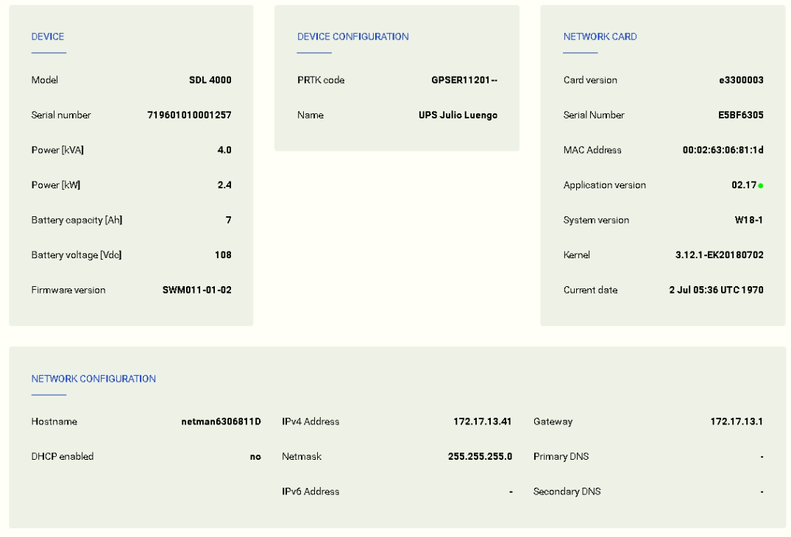

.1.3.6.1.4.1.5491.10.1.1.3.0
.1.3.6.1.4.1.5491.10.1.1.12.0
.1.3.6.1.4.1.5491.10.1.1.9.0 / 1000
.1.3.6.1.4.1.5491.10.1.1.10.0 / 1000
.1.3.6.1.4.1.5491.10.1.1.11.0
.1.3.6.1.4.1.5491.10.1.1.2.0
.1.3.6.1.4.1.5491.10.1.1.4.0
.1.3.6.1.4.1.5491.5.1.1.8.0
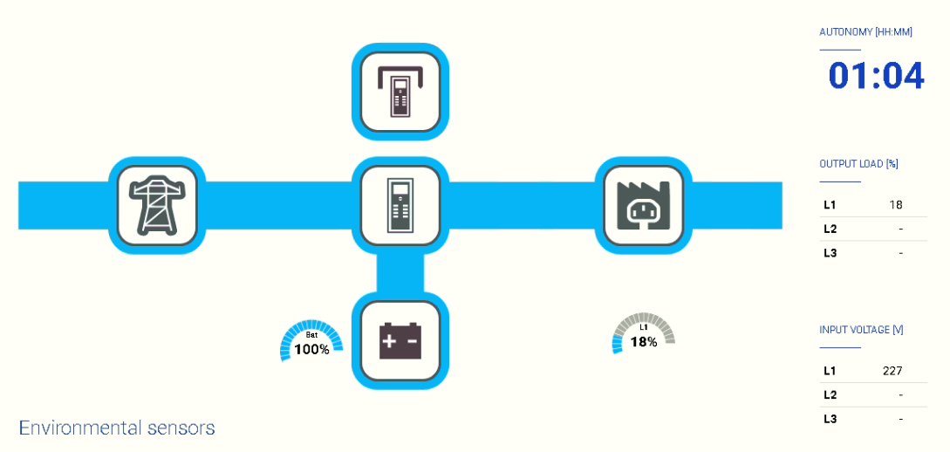
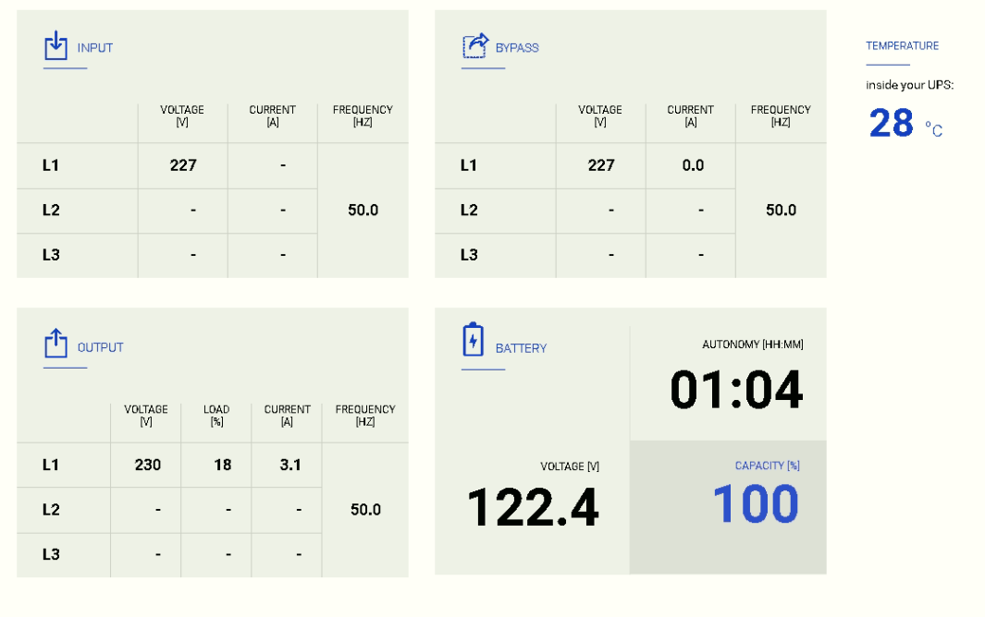
BYPASS POWER, CURRENT > 0
INPUT VOLTAGE > 0
.1.3.6.1.4.1.5491.10.1.2.4.0
OUTPUT LOAD
OUTPUT CURRENT >0
.1.3.6.1.4.1.5491.10.1.4.1.0
INTEGER {other(1),none(2),normal(3),bypass(4),battery(5),booster(6),
reducer(7)}
The present source of output power. The enumeration
none(2) indicates that there is no source of output
power (and therefore no output power), for example,
the system has opened the output breaker.

.1.3.6.1.4.1.5491.10.1.4.4.1.5 (3)
.1.3.6.1.4.1.5491.10.1.4.4.1.6 (3)
PEAK CURRENT (W)
POWER (W)
.1.3.6.1.4.1.5491.10.1.4.4.1.4 (3)
.1.3.6.1.4.1.5491.10.1.4.4.1.3 (3)
.1.3.6.1.4.1.5491.10.1.4.4.1.2 (3)
.1.3.6.1.4.1.5491.10.1.4.2.0
.1.3.6.1.4.1.5491.10.1.3.3.1.5 (3)
POWER (W)
.1.3.6.1.4.1.5491.10.1.3.3.1.4 (3)
.1.3.6.1.4.1.5491.10.1.3.3.1.3 (3)
.1.3.6.1.4.1.5491.10.1.3.3.1.2.1
POWER (W)
.1.3.6.1.4.1.5491.10.1.5.3.1.4 (3)
.1.3.6.1.4.1.5491.10.1.5.1.0
.1.3.6.1.4.1.5491.10.1.5.3.1.3 (3)
.1.3.6.1.4.1.5491.10.1.5.3.1.2 (3)
.1.3.6.1.4.1.5491.10.1.2.3.0
-1 = “-“
.1.3.6.1.4.1.5491.12.2.16.0
.1.3.6.1.4.1.5491.10.1.2.5.0 / 10
.1.3.6.1.4.1.5491.10.1.2.4.0

